Internship Report
Press Tool Design with Catia V5
Design Calculations + 3D Design + 2D Drafting
Insert the Image of the Press Tool Assembly
Insert the Image of the Die Assembly | Insert the Image of the Punch Assembly
Internship Report Submitted By
Your Name
Internship carried out at
HTTPS://ELEARN.ROYAL-MECHANICAL.COM/
An e-learning initiative from
Maxpertise Technology Labs Pvt. Ltd., Bengaluru.
About the Company
https://elearn.royal-mechanical.com/
https://elearn.royal-mechanical.com/ is an online school for mechanical engineers owned by Maxpertise Technology Labs Pvt. Ltd.
The objective of https://elearn.royal-mechanical.com/ is to offer job-oriented courses for mechanical engineers and bridge the gap between academia and the industry.
https://elearn.royal-mechanical.com/ offers job-oriented online courses in the below areas
CAD Skills | Technical Skills | Soft Skills
- Catia v5  - Fusion 360 | - Tooling Design – Jigs, Fixtures, and Press Tools  - Product Design – Automotive, Aerospace, and Industrial Automation.  - Geometric Dimensioning and Tolerancing (GD&T) | How to Get Mechanical Engineering Jobs?  Spoken English for Mechanical Engineers
https://elearn.royal-mechanical.com/ offers job-oriented online courses in the below domains

Automotive

Aerospace

Industrial Automation
Please visit https://elearn.royal-mechanical.com/ for more information.

Internship Certificate
(After Printing the Report,
Replace this page with the
Internship Certificate provided by Maxpertise Technology Labs Pvt. Ltd.)

The objective of this Internship
Below are the top three objectives of the Internship at Maxpertise Technology Labs Pvt. Ltd., Bengaluru.
 |  | (3)
Learn Catia V5 | Learn the Design of Blanking Die (Press Tool) | Design of Blanking Die (Press Tool)
Learn the below-mentioned modules of Catia V5  - Sketcher workbench  - Part design workbench  - Assembly workbench  - Drafting workbench | Learn the Design of Blanking Die for the "Power Screw Support Bracket" of a "Car Scissor Jack"  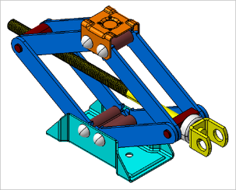 | Mini Project: Design of Blanking die using Catia V5 for the below part.  Insert the component/part drawing  (Refer to Sample Report for Reference)
Table 1: Objectives of Internship

About Catia V5
Catia is a Software developed by the French company DASSAULT SYSTEMES, which is used for
- CAD (Computer-Aided Design)
- CAM (Computer-Aided Manufacturing)
- CAE (Computer-Aided Engineering)
Full-Form of CATIA is a Computer-Aided Three-dimensional Interactive Application.
Catia V5 is the most preferred design software by the world's leading companies in Automotive, Aerospace, Defence, Transportation, Medical Devices, Industrial Machinery, Ship Building, Architecture, Construction, Power, Petroleum, Engineering Services, and many more.

About the Press & Press Tool
Press: A Press is a Machine that provides the Force necessary to cut/form the sheet metal workpiece
Press Tool: A "Press Tool" is a "Tool" which cuts or forms the sheet metal workpiece. "Press Tool" is also called "Stamping Die." Press Tool is used predominantly in the automotive industry.

About Blanking
Blanking is a shearing operation performed on the sheet metal.
The Blank (Useful Product) is sheared from the Raw Material (Sheet Metal Strip)
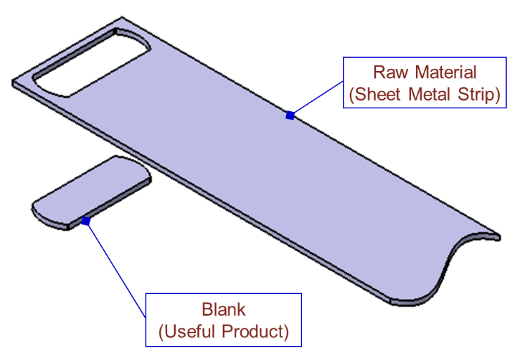
Figure 1: Blanking Operation

Cutting Clearance
Cutting Clearance: The space/gap between Punch's cutting edge and the cutting edge of the die. Proper clearance is very much essential for the shearing to happen.
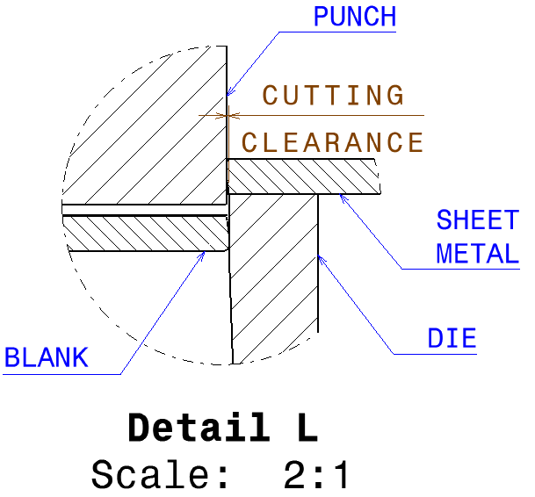
Figure 2: Illustration of Cutting Clearance

Cutting Clearance for Blanking (6% to 8% of sheet metal thickness)
Precision Blanking = 6% of sheet metal thickness
Ordinary Blanking = 8% of sheet metal thickness
Table 2: Values of Cutting Clearance

The Design Process
Below mentioned flow chart depicts the design process to design the Blanking Die (Press Tool)
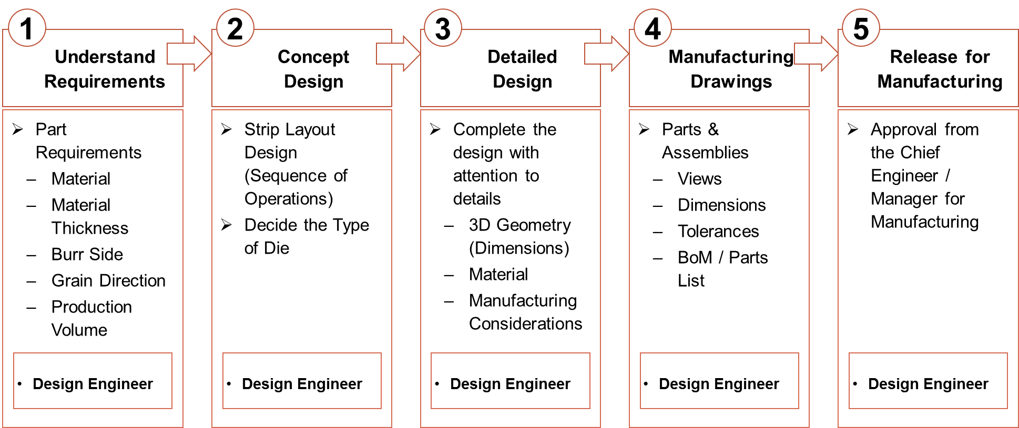
Figure 3: The Design Process

Design of Blanking Die (Press Tool)

Understand Requirements
Below mentioned drawing depicts the part drawing for which the Blanking die (press tool) is designed.
Insert the component/part drawing
(Refer to Sample Report for Reference)
Figure 4: The Part Drawing

The Part Material
As per the part drawing, the part material is LOW CARBON HIGH STRENGTH COLD ROLLED STEEL AS PER IS 14491 of GRADE: 260Y
As per IS 14491, for LOW CARBON HIGH STRENGTH COLD ROLLED STEEL AS PER IS 14491 of GRADE: 260Y
σ_{y} = 260 N/mm2
σ_{t} = 350 N/mm2

The Part Material Thickness
As per the part drawing, the part material thickness is 3.15mm.

Concept Design (Strip Layout Design)
Below mentioned flow chart depicts the design process to design the Strip Layout.
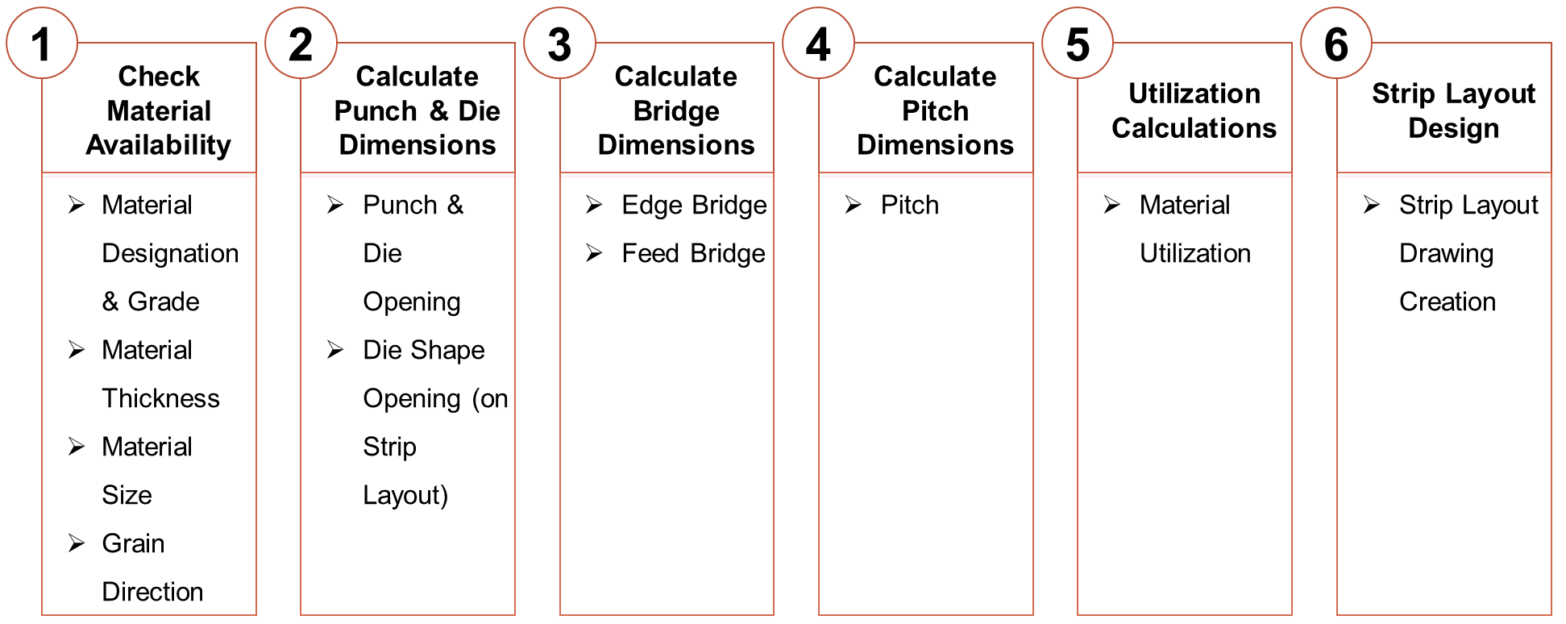
Figure 5: The Strip Layout Design Procedure

Check Material Availability
Of all the sizes available with the material supplier, below mentioned raw material size is selected.
Length = 2500mm
Width = 1000mm
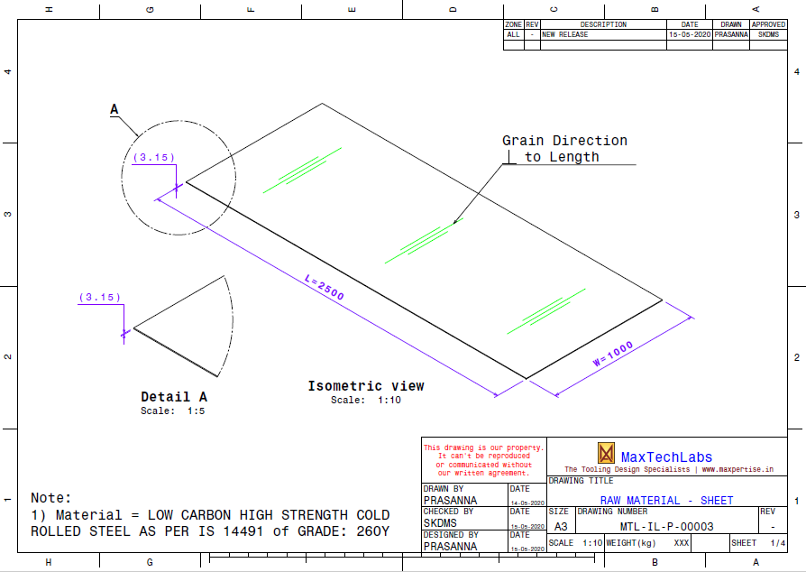
Figure 6: Raw Material Size

The Raw material can be slit along its length or its width.
Slit along Length | Slit Along Width
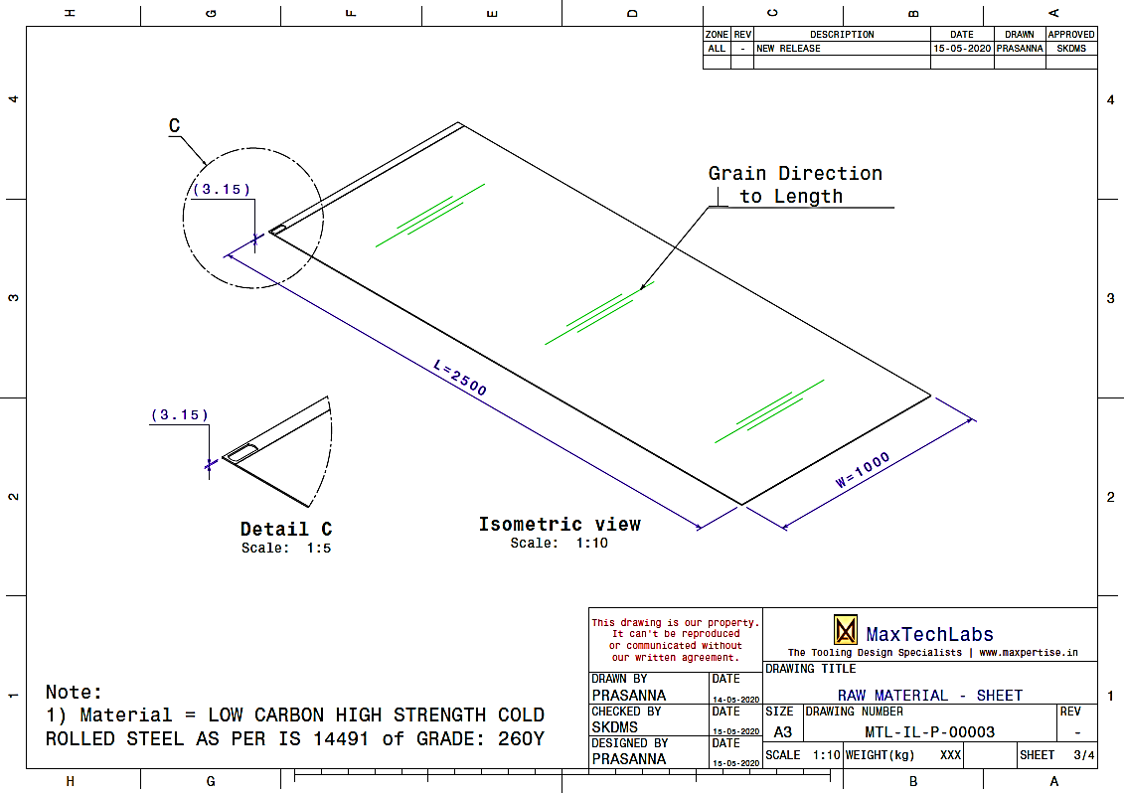 | 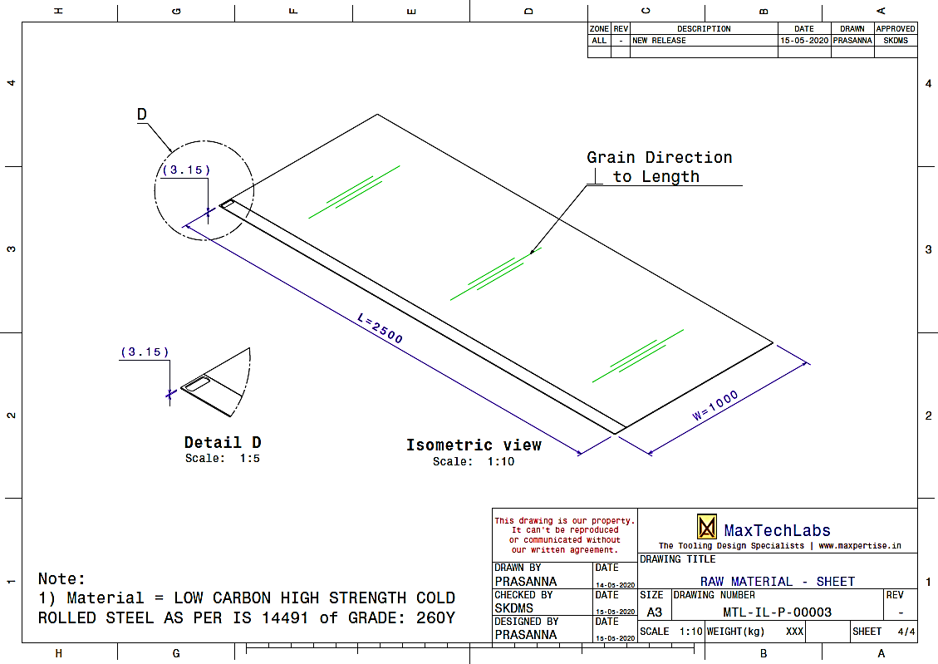
Figure 7: Raw Material Slitting

Calculate Punch & Die Dimensions
Calculations – Cutting Clearance, Punch Shape & Die Shape
Cutting Clearance  (Considering Ordinary Blanking) | = 8% of sheet metal thickness
 | = 8% x 3.15 mm
 | = 0.252 mm
Die Opening Dimension | = Component Dimension
 | = Enter the Design Calculations to Calculate the Die Opening Dimension
Punch Shape Dimension | = Component Dimension - (2 * Cutting Clearance)
 | = Enter the Design Calculations to Calculate the Punch Opening Dimension
Table 3: Calculations – Cutting Clearance, Punch Shape & Die Shape

Calculate the Bridge Dimensions
Feed Bridge is a function of the length of the component.
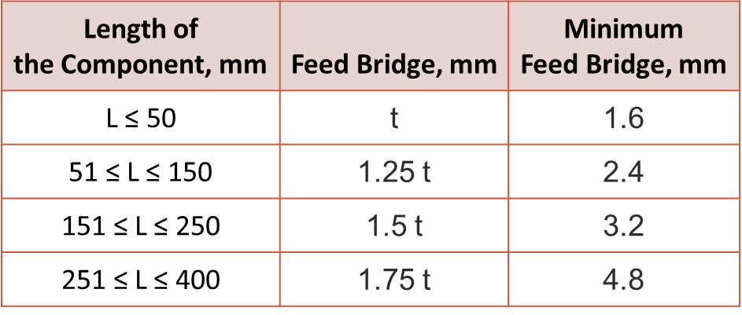
Table 4: Feed Bridge Dimensions

Calculations – Feed Bridge & Edge Bridge
Feed Bridge | = 1.25 * t
 | = 1.25 * 3.15
 | = 3.9375 mm
Edge Bridge | = 1.2 * 3.9375
 | = 4.725 mm
Table 5: Calculations – Feed Bridge & Edge Bridge

Slit along Length | Slit Along Width
Insert the Image of the component being sheared, when raw material is slit along the length.  Indicate Feed Bridge Dimensions in the Image | Insert the Image of the component being sheared, when raw material is slit along the width.  Indicate Feed Bridge Dimensions in the Image
Figure 8: Feed Bridge Dimensions

Slit along Length | Slit Along Width
Insert the Image of the component being sheared, when raw material is slit along the length.  Indicate Edge Bridge Dimensions in the Image | Insert the Image of the component being sheared, when raw material is slit along the length.  Indicate Edge Bridge Dimensions in the Image
Figure 9: Edge Bridge Dimensions

Calculate the Pitch
Slit along Length |  | Slit Along Width
Pitch | = Edge Bridge + Shape Opening Width | Pitch | = Edge Bridge + Shape Opening Length
 | = Enter the Design Calculations to Calculate the Pitch when the raw material is slit along the length |  | = Enter the Design Calculations to Calculate the Pitch when the raw material is slit along the width
Insert the Image of the component being sheared, when raw material is slit along the length.  Indicate Pitch Dimensions in the Image |  | Insert the Image of the component being sheared, when raw material is slit along the length.  Indicate Pitch Dimensions in the Image
Figure 10: Pitch Dimensions

Calculate the Material Utilization

Calculations – Total Number of Components
 |  | 1. Slit along the Length | 2. Slit along the width
Strip Width | = | Enter Design Calculations | Enter Design Calculations
Strip Width with Tolerance | = | Enter Design Calculations | Enter Design Calculations
MMC of Strip Width | = | Enter Design Calculations | Enter Design Calculations
No. of Strips per Sheet Metal | = | $\frac{Sheet Metal Width}{MMC of Strip Width}$ | $\frac{Sheet Metal Length}{MMC of Strip Width}$
 | = | Enter Design Calculations | Enter Design Calculations
No. of Components per Strip | = | $\frac{Sheet Metal Length}{Pitch}$ | $\frac{Sheet Metal Width}{Pitch}$
 | = | Enter Design Calculations | Enter Design Calculations
Total No. of Components per Sheet Metal | = | No. of Strips per Sheet Metal x No. of Components per Strip | No. of Strips per Sheet Metal x No. of Components per Strip
 | = | Enter Design Calculations | Enter Design Calculations
Table 6: Calculations – Total Number of Components

By slitting the sheet metal along its length, we produce more components.
Utilization Calculations for Slit along the Length
Total No. of Components per Sheet Metal | = | Enter Design Calculations
Area of Component | = | Enter Design Calculations
Material Utilization | = | $$\frac{\text{Total }\text{Utilized Area}}{Area of Sheet Meal}$$
 | = | Enter Design Calculations
Table 7: Utilization Calculations

Final Design of the Strip Layout Drawing
Insert the Strip Layout Drawing
(Refer to Sample Report for Reference)
Figure 11: Strip Layout Drawing

Force and Tonnage Calculations

Perimeter Calculations
Insert the Component Perimeter Calculations Drawing
(Refer to Sample Report for Reference)
Figure 12: Component Perimeter

Perimeter Calculations
Perimeter | = | Enter Design Calculations
 | = | Enter Design Calculations
Table 8: Perimeter Calculations

Shear Force Calculations
The formula to calculate the Shear Force is
F_{sh} = $\frac{0.8 * p * t *TS}{1000}$
Calculations – Shear Force
F_{sh} | = | Shear Force | tonnes | Enter Design Calculations
p | = | Perimeter of Shear | mm | Enter Design Calculations
t | = | Thickness of Sheet | mm | = 3.15
TS | = | Tensile Strength of Material | kg/mm² | = 35.7
Table 9: Shear Force Calculations

Tonnage Calculations
The formula to calculate the press tonnage is
PT = 1.5 * F _{sh}
Press Tonnage Calculations:
PT | = | Press Tonnage | tonnes | Enter Design Calculations
F_{sh} | = | Shear Force | tonnes | Enter Design Calculations
Table 10: Press Tonnage Calculations

Press Selection & Specifications
Press Capacity / Tonnage ≥ Calculated Press Tonnage
We will design the press tool for the 40tonnes Press available in the production facility.
Below mentioned Press shall be used for component production.

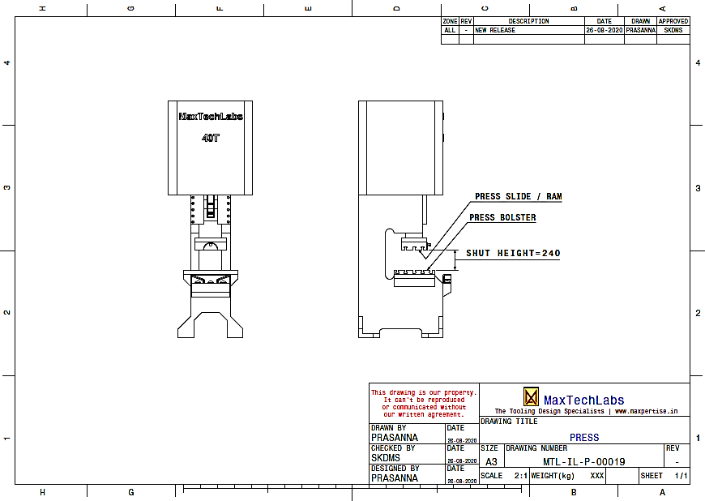
Figure 13: Press

Press Bolster Drawing is shown below.

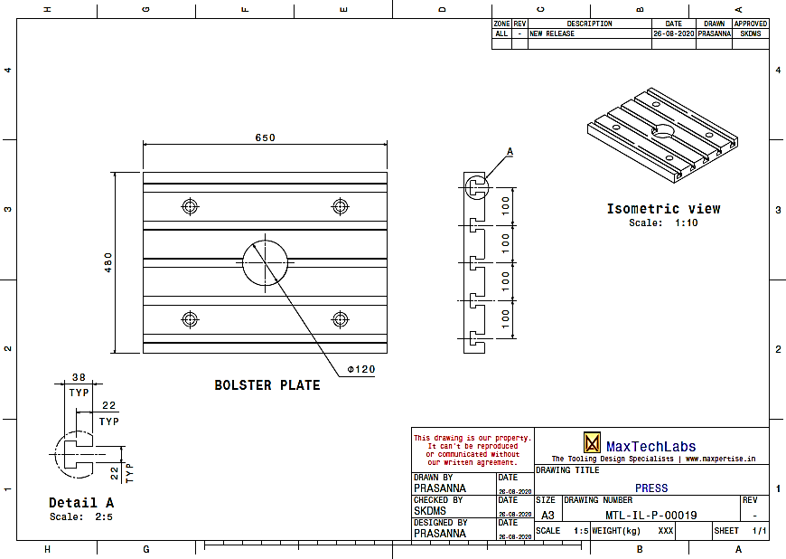
Figure 14: Press Bolster

The press Adapter Plate Drawing is shown below.

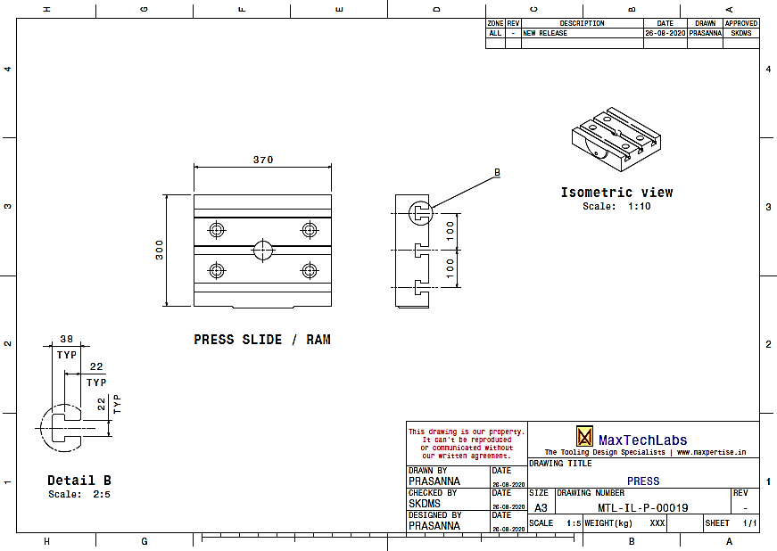
Figure 15: Press Adapter Plate

Detail Design
The design of the press tool is created using Catia V5 software. All essential calculations related to the press tool design are outlined in this chapter.

Die Plate
The die plate provides the cutting edge for shearing or blanking the sheet metal strip.
The formula to calculate the die plate thickness is
T_{d} $=\text{∛}$ ($\frac{Fsh *L3}{16 * E * W * δ})$
Die Plate Thickness Calculations
𝞭 | = | Max. Allowable Die Plate Deflection | mm | = 0.08
F_{sh} | = | Shear Force | kg | Enter Design Calculations
L | = | Length of Die Plate | mm | Enter Design Calculations
E | = | Young's Modulus of Steel | Kg/mm² | = 21.4 x 10³
W | = | Width of Die Plate | mm | Enter Design Calculations
T_{d} | = | The thickness of the Die Plate | mm | Enter Design Calculations | Enter Design Calculations
Table 11: Die Plate Thickness Calculations

The 3D design of the Die Plate using Catia V5 is shown below.
Insert the Image of Die Plate
(Refer to Sample Report for Reference)
Figure 16: Die Plate

Locator Pin
The function of the locator pin is to locate the sheet metal strip along the feed direction.
The 3D design of the Locator Pin using Catia V5 is shown below.
Insert the Image of Locator Pin
(Refer to Sample Report for Reference)
Figure 17: Locator Pin

Strip Guide Plates and the Strip Support Plate
The function of the strip guide plates is to guide the sheet metal strip.
The function of the strip support plate is to support the sheet metal strip.
The 3D design of the Locator Pin using Catia V5 is shown below.
Insert the Image of Strip Gude Plates and Strip Support Plate
(Refer to Sample Report for Reference)
Figure 18: Strip Guide Plates and Strip Support Plate

Strip Pusher
The strip pusher's function is to push the sheet metal strip against the rear strip guide plate. The strip pusher is spring-loaded.
Below mentioned is the procedure for designing the spring.

Figure 19: Spring Design Procedure

Strip Weight Calculations
Strip Width, W | Enter Design Calculations
Strip Length, L | = 2500 mm
Strip Thickness, T | = 3.15 mm
Strip Volume, V | = W x L x T  Enter Design Calculations
The density of Steel ρ | = 0.000008 kg/mm3
Strip Mass, m | = V x ρ  Enter Design Calculations
Acceleration due to Gravity, a | = 9.8 m/s²
Strip Weight, F | = m x a  Enter Design Calculations
Table 12: Strip Weight Calculations

Push Force Calculations
Strip Weight, F | = 44 N
Co-efficient of Friction (Steel on Steel), μ | ≈ 0.7
Push Force, N | = μ x F  Enter Design Calculations
The spring force ≥ Enter Design Calculations.
Table 13: Push Force Calculations

Spring Length Calculations
SPACE AVAILABLE | Enter Design Calculations
SPACE AVAILABLE | 90% TO 95% OF THE TOTAL LENGTH (FREE LENGTH)
TOTAL LENGTH (FREE LENGTH) | = $\frac{\text{SPACE AVAILABLE}}{\text{90\%}}$  Enter Design Calculations
Generally, Springs are available in steps of 5mm in length.
TOTAL LENGTH (FREE LENGTH) | Enter Design Calculations
Table 14: Spring Length Calculations

Spring Constant Calculations
COMPRESSED LENGTH | = SPACE AVAILABLE - STROKE  Enter Design Calculations
2mm is the interference that we have designed between the Strip Pusher and the Strip
We need the Push Force @ Enter Design Calculations.
SPRING CONSTANT | = $\frac{\text{PUSH FORCE}}{TOTAL STROKE}$  = $\frac{\text{PUSH FORCE}}{\text{TOTAL LENGTH - COMPRESSED LENGTH}}$  Enter Design Calculations
Select a Spring with Spring Constant ≥ Enter Design Calculations.
Table 15: Spring Constant Calculations

Maximum Spring Deflection Calculations
MAXIMUM COMPRESSED LENGTH | = SPACE AVAILABLE – MAXIMUM STROKE  Enter Design Calculations
An additional 1mm is the clearance between the Strip and the Front Strip Guide Plate.
MAXIMUM DEFLECTION | = $\frac{\text{TOTAL LENGTH - MAX. COMPRESSED LENGTH}}{\text{TOTAL LENGTH}}$ x 100  Enter Design Calculations
Select a Spring with an allowable deflection ≥ Enter Design Calculations.
Table 16: Maximum Spring Deflection Calculations

Spring Selection (From Standard Catalogue)
Inner Diameter, Di | Enter Design Calculations
Outer Diameter, Do | Enter Design Calculations
Wire Diameter, d | Enter Design Calculations
Free Length, L | Enter Design Calculations
Maximum Force, N | Enter Design Calculations
Spring Constant, N/mm | Enter Design Calculations
Max. Allowable Deflection (% of Free Length) | Enter Design Calculations
Table 17: Strip Pusher Spring Specifications

The 3D design of Strip Pusher using Catia V5 is shown below.
Insert the Image of Strip Pusher
(Refer to Sample Report for Reference)
Figure 20: Strip Pusher

Die Back Plate
The function of the die backplate is to absorb energy/force coming from the die plate.
The 3D design of the Die Back Plate using Catia V5 is shown below.
Insert the Image of Die Back Plate
(Refer to Sample Report for Reference)
Figure 21: Die Back Plate

Die Shoe
The function of the die shoe is listed below
- Absorbs the Force coming from the Die Plate.
- Used to Fasten the Die Assembly to Press Bolster using U-Slots
- Has Provision to mount the Guide Pillars.
The 3D design of Strip Pusher using Catia V5 is shown below.
Insert the Image of Die Shoe
(Refer to Sample Report for Reference)
Figure 22: Die Shoe

Guide Pillar
Guide pillars and guide bushes are used to locate the die and punch assemblies.
Below mentioned is the procedure for designing the Guide Pillar.
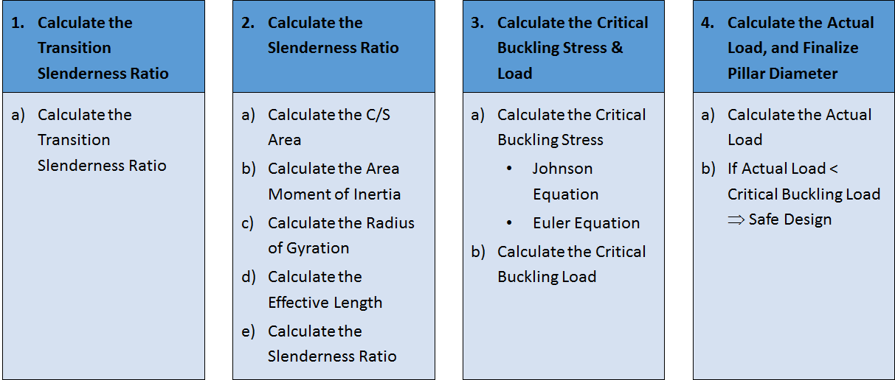
Figure 23: Design Procedure – Guide Pillar

The formula to calculate the Transition Slenderness Ratio is
TSR = $\sqrt{\frac{2 π2 E}{Sy}}$
Transition Slenderness Ratio Calculations
E | = | Young's Modulus of Steel | N/mm² | = 210 x 10³
$$Sy$$ | = | Yield Strength of Steel | N/mm² | = 250
TSR | = | Transition Slenderness Ratio | - | Enter Design Calculations
Table 18: Transition Slenderness Ratio Calculations

The formula to calculate the Cross-Sectional Area is
A = $\frac{π d2}{4}$
Cross Section Area Calculations (Guide Pillar)
d | = | The diameter of the Pillar | mm | = 20
A | = | Cross-Sectional Area | mm² | Enter Design Calculations
Table 19: Cross-Section Area Calculations (guide Pillar

The formula to calculate the Area Moment of Inertia Calculations is mentioned below.

I = $\frac{π d4}{64}$
Area Moment of Inertia Calculations
d | = | The diameter of the Pillar | mm | = 20
I | = | Area Moment of Inertia | mm⁴ | Enter Design Calculations
Table 20: Area Moment of Inertia Calculations

The formula to calculate the Radius of Gyration is mentioned below.
R_{g} = $\sqrt{\frac{I}{A}}$
The Radius of Gyration Calculations
I | = | Area Moment of Inertia | mm⁴ | Enter Design Calculations
A | = | Cross-Sectional Area | mm² | Enter Design Calculations
R_{g} | = | Radius of Gyration | mm | Enter Design Calculations
Table 21: Radius of gyration Calculations

The formula to calculate the Slenderness Ratio is mentioned below.
SR = $\frac{Le}{Rg}$
Slenderness Ratio Calculations
$$L$$ | = | Length of Pillar | mm | Enter Design Calculations
$$Le$$ | = | Effective Length of Pillar | mm | Enter Design Calculations
R_{g} | = | Radius of Gyration | mm | Enter Design Calculations
SR | = | Slenderness Ratio | - | Enter Design Calculations
Table 22: Slenderness Ratio Calculations

The formula to calculate the Critical Buckling Stress is mentioned below.
$σ$_{cr} = $\frac{π2E}{SR2}$
Critical Buckling Stress Calculations
E | = | Young's Modulus of Steel | N/mm² | = 210 x 10³
SR | = | Slenderness Ratio | - | Enter Design Calculations
$σ$_{cr} | = | Buckling Stress | N/mm² | Enter Design Calculations
Table 23: Critical Buckling Stress Calculations

The formula to calculate the Critical Buckling Load is mentioned below.
$Fcr= σ$_{cr} A
Critical Buckling Load Calculations
$σ$_{cr} | = | Buckling Stress | N/mm² | Enter Design Calculations
A | = | Cross-Sectional Area | mm² | Enter Design Calculations
$F$_{cr} | = | Buckling Load | N | Enter Design Calculations
Table 24: Critical Buckling Load Calculations

Actual Load Calculations
Shear Force, F_{sh} | Enter Design Calculations
No. of Pillars | Enter Design Calculations
Actual Force / Pillar | Enter Design Calculations
Critical Buckling Load, $F$_{cr} | Enter Design Calculations
$F$_{cr} > Actual Force/Pillar
Design is Safe
Table 25: Actual Load Calculations

The 3D design of the Guide Pillar using Catia V5 is shown below.
Insert the Image of Guide Pillar
(Refer to Sample Report for Reference)

Figure 24: Guide Pillar

Stroke End Block
The Stroke End Block acts as a stopper to indicate the bottom dead centre.
The 3D design of Stroke End Blocks using Catia V5 is shown below.

Insert the Image of Stroke End Block
(Refer to Sample Report for Reference)
Figure 25: Stroke End Block

Die Assembly Lifting Hooks
The function of the lifting hooks is to lift the die assembly.
The 3D design of Lifting Hooks using Catia V5 is shown below.

Insert the Image of Lifting Hooks
(Refer to Sample Report for Reference)
Figure 26: Die Assembly Lifting Hooks

Screws and Dowels for Die Assembly
The screws are used to fasten, and the dowels are used to locate the functionally critical parts.
Catalog parts in Catia V5 are used for the 3D assembly.
Insert the Image of Screws and Dowels of Die Assembly
(Refer to Sample Report for Reference)
Figure 27: Screws and Dowels for Die Assembly

Blanking Punch
The Blanking Punch is combined with a Die Plate to Blank the sheet metal.
It has the cutting edge to shear the sheet metal.
For the blanking operation, the cutting clearance is provided on the Punch.
Cutting clearance Calculations
= 8% of the sheet metal thickness
= 0.08 x 3.15 = 0.252mm
Table 26: Cutting Clearance Calculations

The 3D design of the Blanking Punch using Catia V5 is shown below.
Insert the Image of Blanking Punch
(Refer to Sample Report for Reference)
Figure 28: Blanking Punch

Stripper Plate
The function of the Stripper Plate is to Strip the Sheet Metal Strip from the Punch.
The formula to calculate the stripping Force is
$$Fst=0.1 *Fsh$$
Stripping Force Calculations
F_{st} | = | Stripping Force | tonnes | Enter Design Calculations
F_{sh} | = | Shear Force | tonnes | Enter Design Calculations
Table 27: Stripping Force Calculations

The formula to calculate the thickness of the stripper plate is
T_{s} $=\text{∛}$ ($\frac{Fst *L3}{16 *E *W * δ})$
Stripper Plate Thickness Calculations
𝞭 | = | Max. Allowable Stripper Plate Deflection | mm | = 0.08
F_{st} | = | Stripping Force | kg | Enter Design Calculations
L | = | Length of Stripper Plate | mm | Enter Design Calculations
E | = | Young's Modulus of Steel | Kg/mm² | = 21.4 x 10³
I | = | Moment of Inertia | mm⁴
W | = | Width of Stripper Plate | mm | Enter Design Calculations
T_{s} | = | The thickness of the Stripper Plate | mm | Enter Design Calculations
Table 28: Stripper Plate Thickness Calculations
Below mentioned is the procedure for designing the spring.

Push Force Calculations
PUSH FORCE | = STRIPPING FORCE  Enter Design Calculations
NO. OF SPRINGS | Enter Design Calculations
PUSH FORCE / SPRING | = $\frac{\text{TOTAL }\text{PUSH FORCE}}{NO. OF SPRINGS}$  Enter Design Calculations
Table 29: Spring push Force Calculations

Stripper Stroke Calculations
STRIPPER STROKE | = STRIP THICKNESS + PUNCH ENTRY INTO DIE + 1  Enter Design Calculations
Table 30: Stripper Stroke Calculations

Spring Total Length Calculations
SPACE AVAILABLE | = COMPRESSED LENGTH + STRIPPER STROKE  Enter Design Calculations
SPACE AVAILABLE | 90% TO 95% OF THE TOTAL LENGTH (FREE LENGTH)
TOTAL LENGTH (FREE LENGTH) | = $\frac{\text{SPACE AVAILABLE}}{\text{90\%}}$  Enter Design Calculations
Generally, Springs are available in steps of 5mm in length.
TOTAL LENGTH (FREE LENGTH) | Enter Design Calculations
Table 31: Spring Total Length Calculations

Spring Constant Calculations
COMPRESSED LENGTH | Enter Design Calculations
@60mm, we need the Push Force of Enter Design Calculations
SPRING CONSTANT | = $\frac{\text{PUSH FORCE}}{SPRING STROKE}$  = $\frac{\text{PUSH FORCE}}{\text{TOTAL LENGTH - COMPRESSED LENGTH}}$  Enter Design Calculations
Select a Spring with Spring Constant ≥ Enter Design Calculations.
Table 32: Spring Constant Calculations

Spring Maximum Deflection Calculations
MAXIMUM COMPRESSED LENGTH | Enter Design Calculations
TOTAL LENGTH (FREE LENGTH) | Enter Design Calculations
MAXIMUM DEFLECTION | = $\frac{\text{TOTAL LENGTH - COMPRESSED LENGTH}}{\text{TOTAL LENGTH}}$ x 100  Enter Design Calculations
Select a Spring with an allowable deflection ≥ Enter Design Calculations.
Table 33: Spring Maximum Deflection Calculations

Spring Selection
Free Length, L | Enter Design Calculations
Spring Constant, N/mm | ≥ Enter Design Calculations
Maximum Allowable Deflection (% of Free Length) | ≥ Enter Design Calculations
Inner Diameter, Di | Enter Design Calculations
Outer Diameter, Do | Enter Design Calculations
Spring Constant, N/mm | Enter Design Calculations
Table 34: Stripper Spring Specifications

The stripper plate's 3D design, the die spring, and the shoulder bolt using Catia V5 are shown below.

Insert the Image of Stripper Plate, Stripper Springs, and Shoulder Bolt
(Refer to Sample Report for Reference)
Figure 29: Stripper Plate, Stripper Springs, and Shoulder Bolt

Punch Holder
The Function of the Punch Holder is to Hold and Accurately Position the Punch.
The 3D design of the Punch Holder using Catia V5 is shown below.

Insert the Image of Punch Holder
(Refer to Sample Report for Reference)
Figure 30: Punch Holder

Punch Back Plate
The Function of the Punch Back Plate is to Absorb the Force coming from the Punch.
The 3D design of the Punch Back Plate using Catia V5 is shown below.
Insert the Image of Punch Back Plate
(Refer to Sample Report for Reference)
Figure 31: Punch Back Plate

Top Plate
The Function of the Top Plate is listed below
- Holds all the parts of the Punch Assembly.
- Absorbs the Force coming from the Punch and the Punch Back Plate.
- Used to Fasten the Punch Assembly to Press Slide / Adaptor Plate using U-Slots
- Has Provision to mount the Guide Bushes.

The 3D design of the Top Plate using Catia V5 is shown below.

Insert the Image of Top Plate
(Refer to Sample Report for Reference)

Figure 32: Top Plate

Guide Bush
Guide pillars and guide bushes are used to locate the die and punch assemblies.
The 3D design of the Guide bush using Catia V5 is shown below.

Insert the Image of Guide Bush
(Refer to Sample Report for Reference)
Figure 33: Guide Bush

Punch Assembly Lifting Hooks
The function of the lifting hooks is to lift the Punch assembly.
The 3D design of Lifting Hooks using Catia V5 is shown below.

Insert the Image of the punch Assembly Lifting Hooks
(Refer to Sample Report for Reference)
Figure 34: Punch Assembly Lifting Hooks

Screws and Dowels for the Punch Assembly
The screws are used to fasten, and the dowels are used to locate the functionally critical parts.
Catalog parts in Catia V5 are used for the assembly.

Insert the Image of Screws and Dowels for Punch Assembly
(Refer to Sample Report for Reference)
Figure 35: Screws and Dowels for Punch Assembly

Manufacturing Drawings
All the manufacturing Drawings, including the assembly drawings of the Press Tools, are shown in this chapter. The drawings are created using Catia V5.

Assembly Drawing (Sheet -1)
Insert the Image of Assembly Drawing
(Refer to Sample Report for Reference)

Assembly Drawing (Sheet -2)
Insert the Image of Assembly Drawing
(Refer to Sample Report for Reference)

